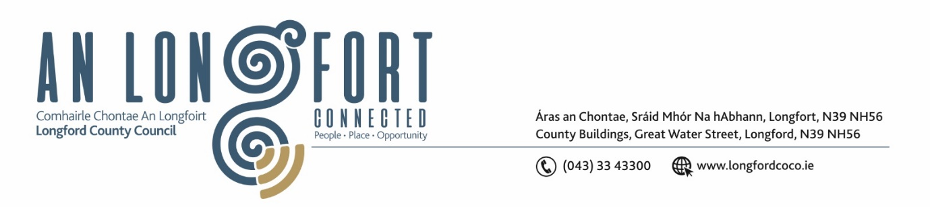

***Please note meeting will be held in the Council Chamber and via Microsoft Teams.***

6 Meitheamh 2023

**Chuig: Gach Ball don Chomhairle**

A Chomhairleoir,

Iarrtar ort bheith i láthair ag Cruinniú Míosuil Chomhairle Chontae Longfoirt a tionólfar i Seomra na Comhairle, Aras an Chontae, Longford agus via MS Teams are an **Chéadaoin 14ú Meitheamh 2023 ag** **4pm** chun gnó a dhéanamh d’réir an Chláir thíos.

You are requested to attend the Monthly Meeting of Longford County Council to be held in the **Council Chamber and via Microsoft Teams** on **Wednesday 14 June 2023 at 4pm** to transact business, as set out on the Agenda hereunder.

Mise le meas,

**__________________**

***Claire McNabola***

***Meetings Administrator.***

**C L Á R**

Prayer before meeting.

1. Confirmation of Minutes:
2. Monthly meeting of Longford County Council held on 10 May 2023 - enclosed
3. Committee meeting of Longford County Council held on 27 April 2023 - enclosed
4. Committee meeting of Longford County Council held on 28 April 2023 – enclosed
5. Matters Arising.

**3.** Declaration of Interest by Members.

1. To note Management Report – To Follow

**5.** To note adopted Minutes of Corporate Policy Group Meeting held on the

11 April 2023 – enclosed.

**6. Housing, Planning, Regeneration & Capital Projects**

1. To note Planning Applications received since last meeting of the Council.
2. Consideration of disposal of Property – Ground plot at Church View, Lanesborough, Co Longford, in accordance with the terms of Section 183 of the Local Government Act 2001 issued on the 9 May 2023 – as circulated.
3. Notice of Motions, submitted by Councillors, as listed hereunder

**Councillor Seamus Butler**

Noting that the 2022 census is now over a year past, I am proposing that LCC commence the review of the County Development Plan. Special consideration should be given to all categories that are affected by the 14.1% increase in population and the pressing need to provide extensive affordable housing. The revenue should also address all other facilities affected by the biggest national population increase in Co Longford, including health, education, water & sewerage, transport and especially the N4 upgrade. Special consideration should be given to allowing temporary sewage treatment solutions, as they are in other counties in conjunction with Uisce Eireann, in Edgeworthstown and Ballymahon where the currently sewage treatment plants are at full capacity.

**7. Community,** **Library and Cultural Services, Corporate and Human Resources**

**(a)** Notice of Motions, submitted by Councillors, as listed hereunder

**Councillors Gerry Warnock and Mark Casey**

We are calling on Longford County Council to provide a live streaming and play back option of all statutory public meetings (including monthly meetings of LCC and the various MDs). The people we represent need to have more access to observe what is happening at these meetings and to exercise their right to transparent and open local government. We understand that the technology currently in situ is compatible to making this happen and we hope that this can be expediated in as short a timeframe as possible.

**Councillor Gerry Warnock**

I am calling on Longford County Council to write to the Minister for Local Government and ask him to consider the reinstatement of Town Councils for towns with a population over 10k people. The last nine years has shown that despite the very best efforts of the Elected Members, the current model is not working for towns such as Longford, and we are falling behind due to the lack of focus and ambition required to positively impact on the development of our county town. Currently, Longford County Council doesn't have that primary ambition, so the only hope we have in reestablishing pride, confidence and prosperity in Longford Town is to reinstate a local authority where that objective is the sole ambition

**8. Votes of Sympathy**